**Form Validation Rules or Restrictions or Constraints**

**Screen 1**

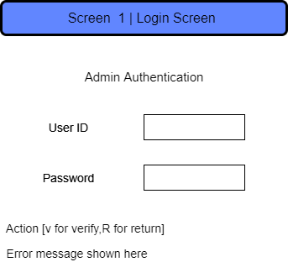

**Rules for user ID: -**

* Cannot be blank
* Minimum length 4
* Maximum length 50

**Rules for Password:** -

* Cannot be blank
* Minimum length 4
* Maximum length 50

**Screen 1.1.1.1**

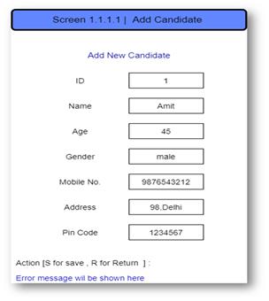

**Rules for ID: -**

* Unique
* Auto increment
* Integer Type
* Maximum limit 4,29,49,67,295

**Rules for Name: -**

* Cannot be blank
* Minimum length 4
* Maximum length 50
* Can have alphabet (a-z, A-Z), dot (.) and space only

**Rules for age: -**

* Cannot be blank
* Integer Data
* Minimum 18

**Rules for Gender: -**

* Cannot be blank
* Fix length 10
* Only digit is allowed
* Gender can be any of three choices (Male, Female, Trans)

**Rules for Mobile Number: -**

* Cannot be blank
* Can be 10 characters only
* All 10 character must be digit

**Rules for address: -**

* Cannot be blank
* Minimum length 4
* Maximum length 50

**Rules for Pin code: -**

* Cannot be blank
* Can be 6 characters are allowed
* Only digits are allowed

**Screen 1.1.1.3**

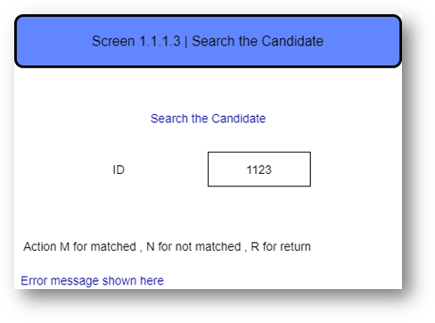

**Rules for ID: -**

* Cannot be blank
* Minimum length 4
* Maximum length 50
* Can be 6 character long

**Screen 1.1.1.4**

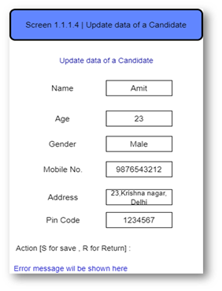

**Rules for Name: -**

* Cannot be blank
* Minimum length 4
* Maximum length 50
* Can have alphabet (a-z, A-Z), dot (.) and space only

**Rules for age: -**

* Cannot be blank
* Integer Data
* Minimum 18

**Rules for Gender: -**

* Cannot be blank
* Fix length 10
* Only digit is allowed
* Gender can be any of three choices (Male, Female, Trans)

**Rules for Mobile Number: -**

* Cannot be blank
* Can be 10 characters only
* All 10 character must be digit

**Rules for address: -**

* Cannot be blank
* Minimum length 4
* Maximum length 50

**Rules for Pin code: -**

* Cannot be blank
* Can be 6 characters are allowed
* Only digits are allowed

**Screen 1.2.1.1**

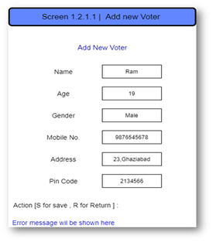

**Rules for Name: -**

* Cannot be blank
* Minimum length 4
* Maximum length 50
* Can have alphabet (a-z, A-Z), dot (.) and space only

**Rules for age: -**

* Cannot be blank
* Integer Data
* Minimum 18

**Rules for Gender: -**

* Cannot be blank
* Fix length 10
* Only digit is allowed
* Gender can be any of three choices (Male, Female, Trans)

**Rules for Mobile Number: -**

* Cannot be blank
* Can be 10 characters only
* All 10 character must be digit

**Rules for address: -**

* Cannot be blank
* Minimum length 4
* Maximum length 50

**Rules for Pin code: -**

* Cannot be blank
* Can be 6 characters are allowed
* Only digits are allowed

**Screen 1.2.1.3**

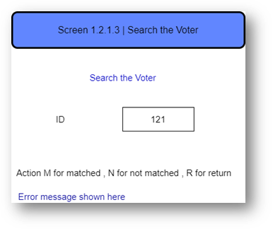

**Rules for ID: -**

* Cannot be blank
* Minimum length 4
* Maximum length 50
* Can be 6 character long

**Screen 1.2.1.4**

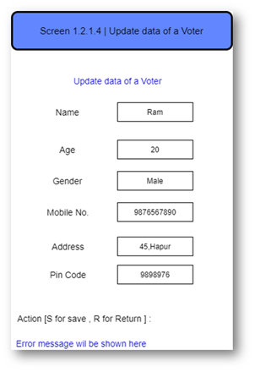

**Rules for Name: -**

* Cannot be blank
* Minimum length 4
* Maximum length 50
* Can have alphabet (a-z, A-Z), dot (.) and space only

**Rules for age: -**

* Cannot be blank
* Integer Data
* Minimum 18

**Rules for Gender: -**

* Cannot be blank
* Fix length 10
* Only digit is allowed
* Gender can be any of three choices (Male, Female, Trans)

**Rules for Mobile Number: -**

* Cannot be blank
* Can be 10 characters only
* All 10 character must be digit

**Rules for address: -**

* Cannot be blank
* Minimum length 4
* Maximum length 50

**Rules for Pin code: -**

* Cannot be blank
* Can be 6 characters are allowed
* Only digits are allowed

**Screen 1.3.1**

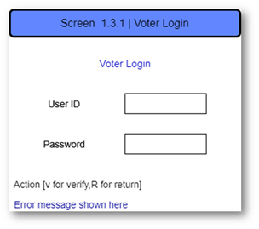

**Rules for user ID: -**

* Cannot be blank
* Minimum length 4
* Maximum length 50

**Rules for Password: -**

* Cannot be blank
* Minimum length 4
* Maximum length 50

**Screen 1.5**

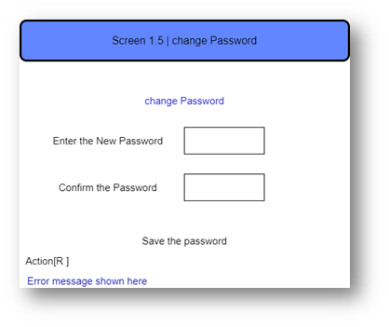

**Rules for enter new password: -**

* Cannot be blank
* Minimum length 4
* Maximum length 50

**Rules for confirm the password: -**

* Password should be same as enter in new password
* Minimum length 4
* Maximum length 5